Technologies we work on

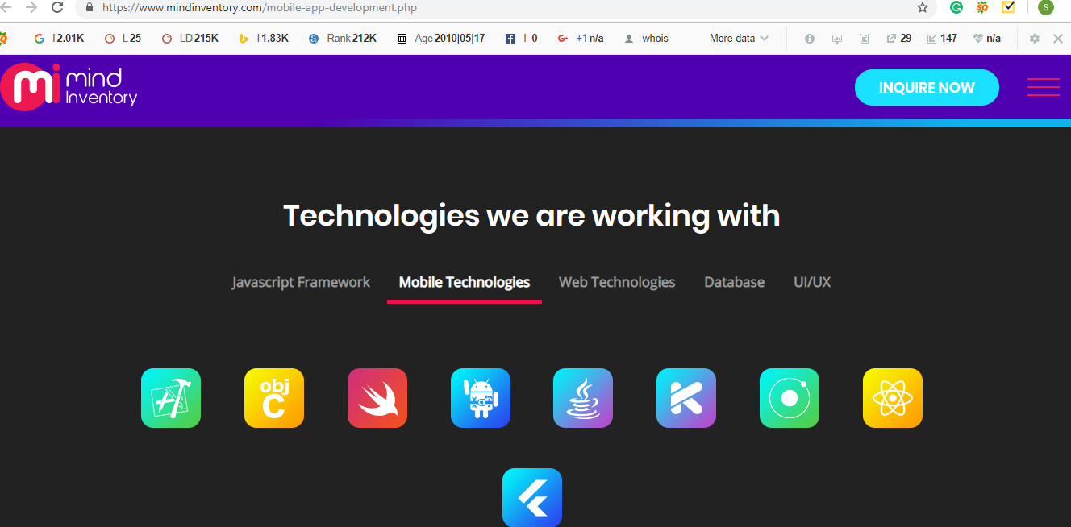

Mobile application developers today are being regularly pushed to produce better application with great user experience so that the apps stand out amongst the competitors. Our mobile application developers look out for leading-edge technologies which can help them meet the demands. Some of the latest mobile technologies such as Xcode, Node.JS, Swift, AndroidSDK, Objective C, PhoneGap, Java, Kotlin, Appcelerator Titanium, Ionic, React, Flutter. We at Nunc Systems believe in building the best mobile applications which gives a best interface along with a great user experience. Our expert team is trained to use the best mobile application development tools and technologies and develop some of the best mobile application available in the market.